Exp 7. Create a Virtual Machine with 1 CPU, 2GB RAM and 15GB storage disk using a Type 2

Virtualization Software, using virtual box.

Step1:Open the virtual box and click on new Osi file

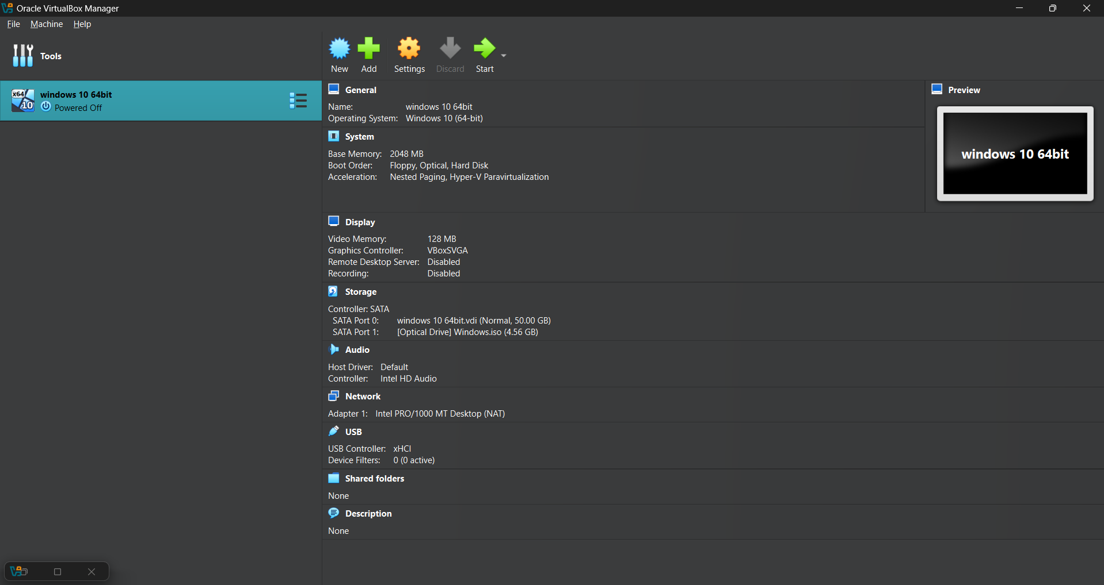

Step 2: 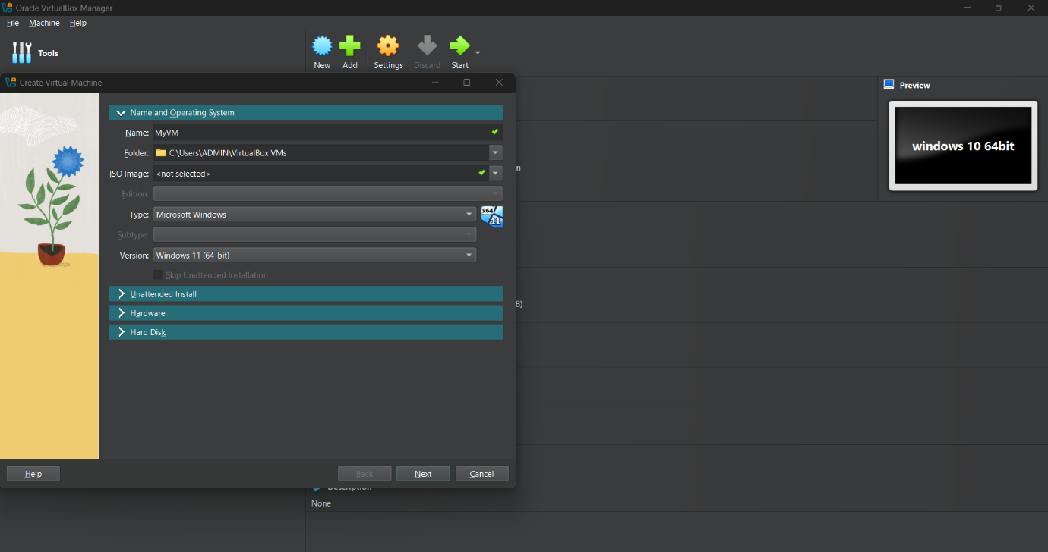

Step 3:

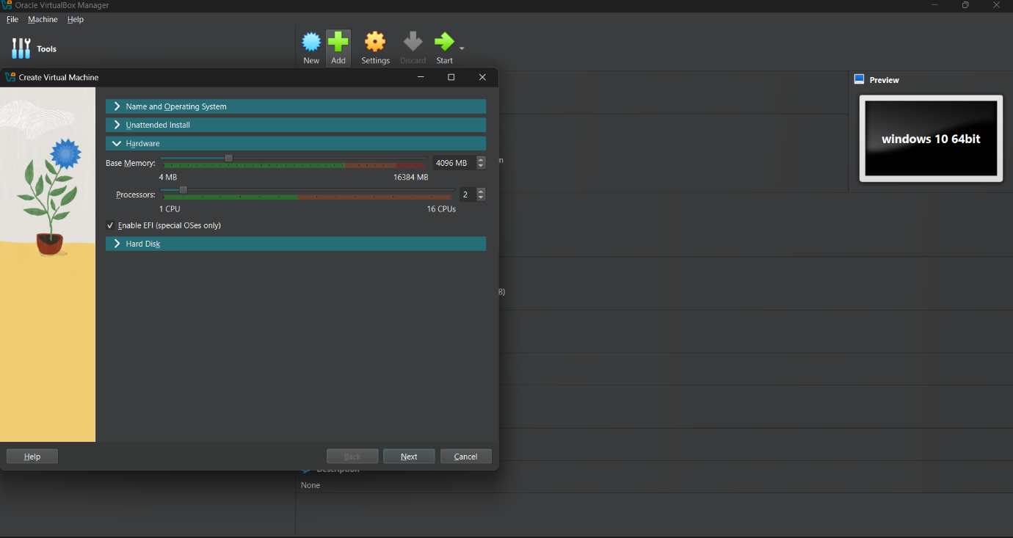

Step 4:

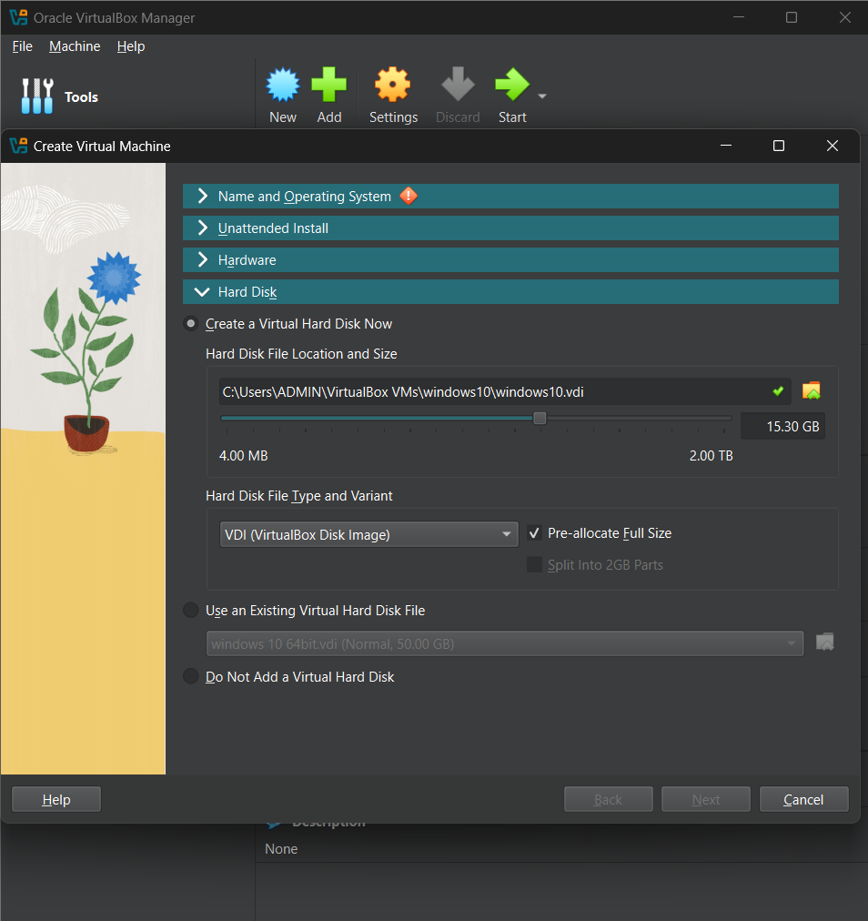

Step 5:Click on start button

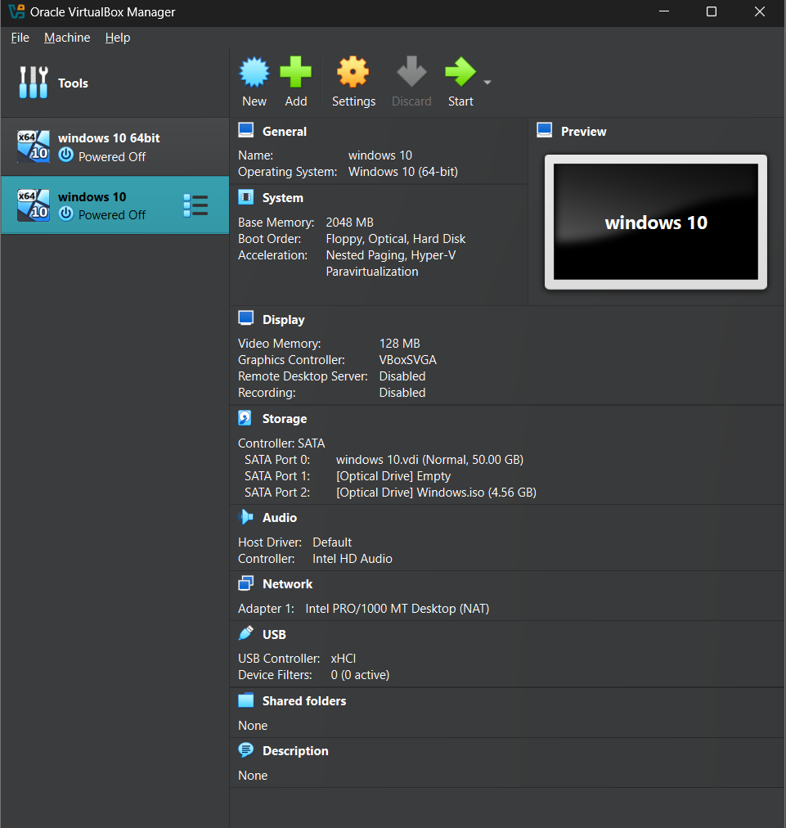

Step 6:

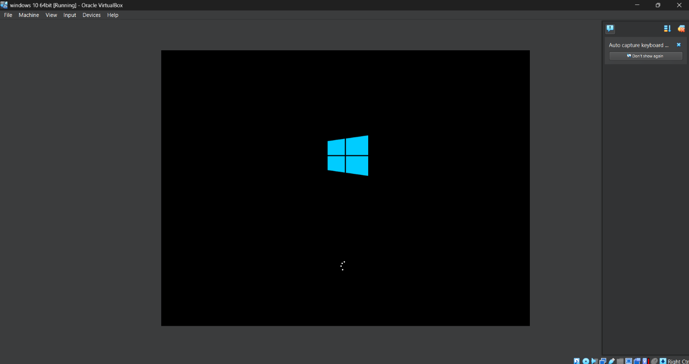

Step 7:

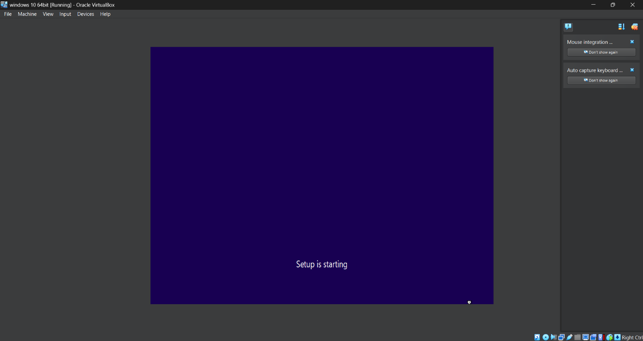

Step 8:

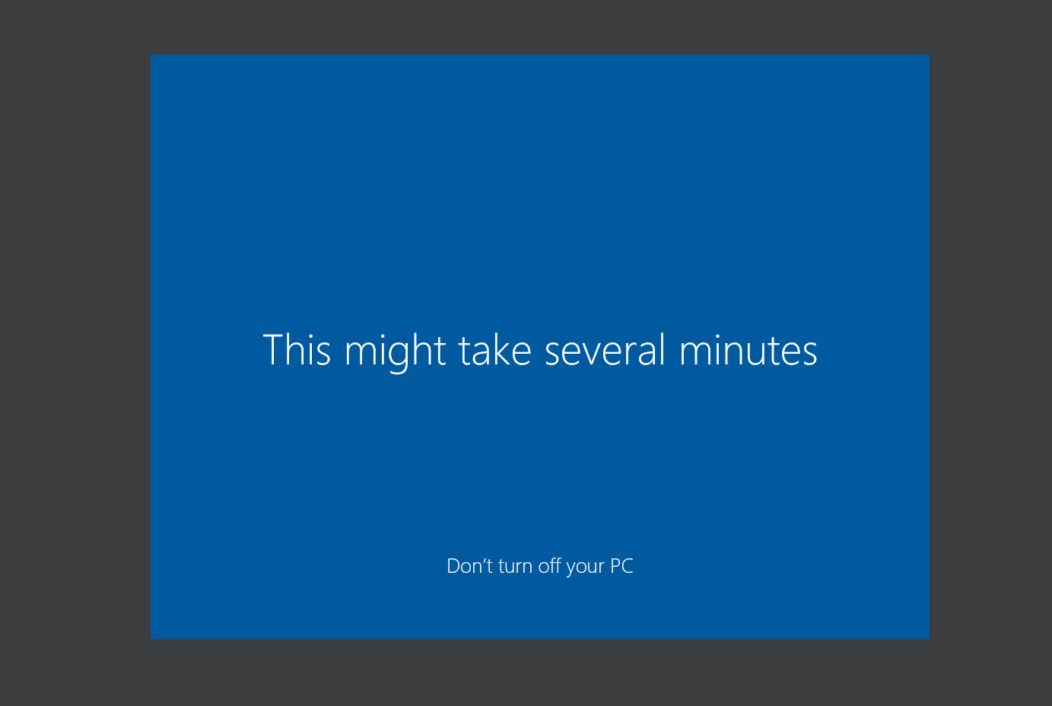

Step 9:

